**Project documentation**

* Dataset:
* It describes data of customers in bank in many categories as age, marital, education and soon.
* And use this to analysis it for make decision for achieve profit for a bank by making relation between columns.
* It’s contained 12000 rows
* It’s contained 17 Columns

1. Age
2. Job
3. Loan
4. Marital
5. Education
6. Default
7. Balance
8. Housing
9. Contact
10. Day
11. Month
12. Duration
13. Campaign
14. Pdays
15. Previous
16. Pout come
17. Deposit

Before Modification:

* First file:

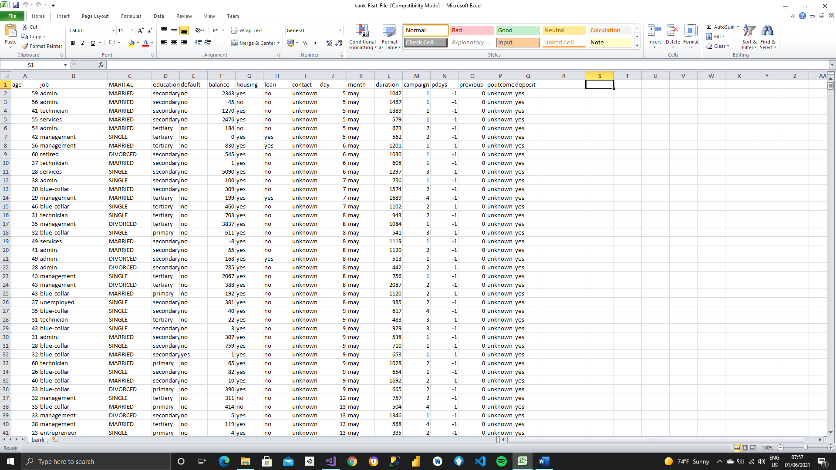

* Second file:

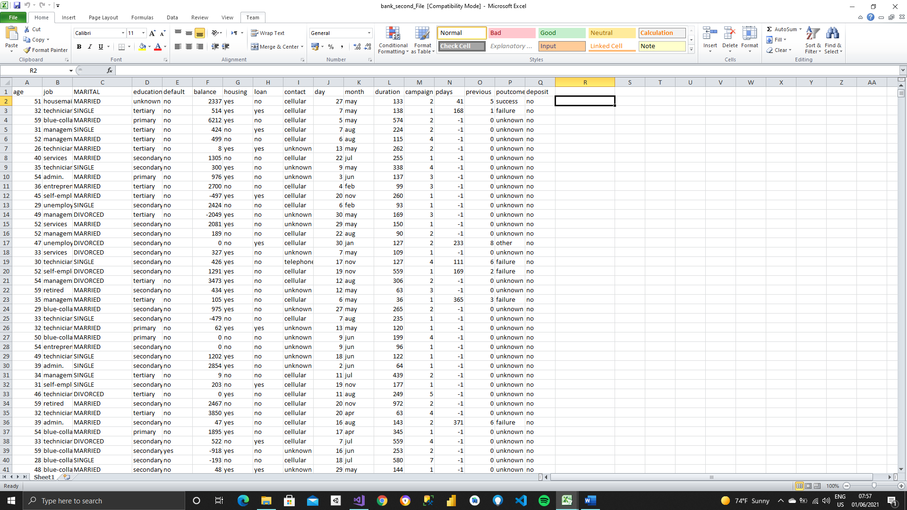

* Functions executied:

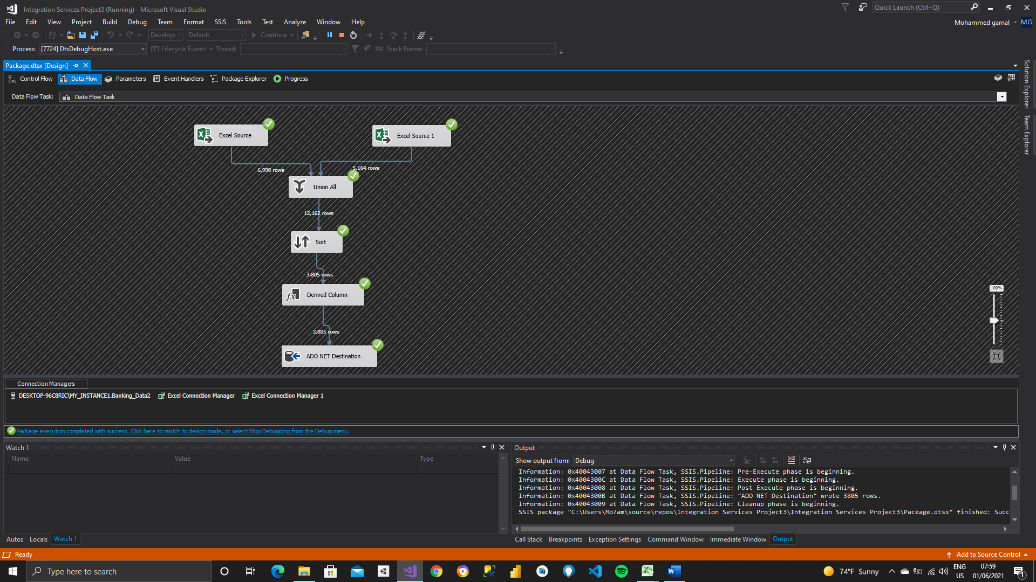

* Transformation:
* First derived column in job column to change into upper word.
* second derived column in marital column to change into lower word.
* third derived column to take first two letter in month column by left function.
* Fourth derived column to take last two letter in month column by right function.
* Fifth derived column to count number of letters in contact column and put its size by Len function.
* Sixth derived column to reverse word in education column by using reverse function.
* Sort by balance column and remove Duplication of all rows.

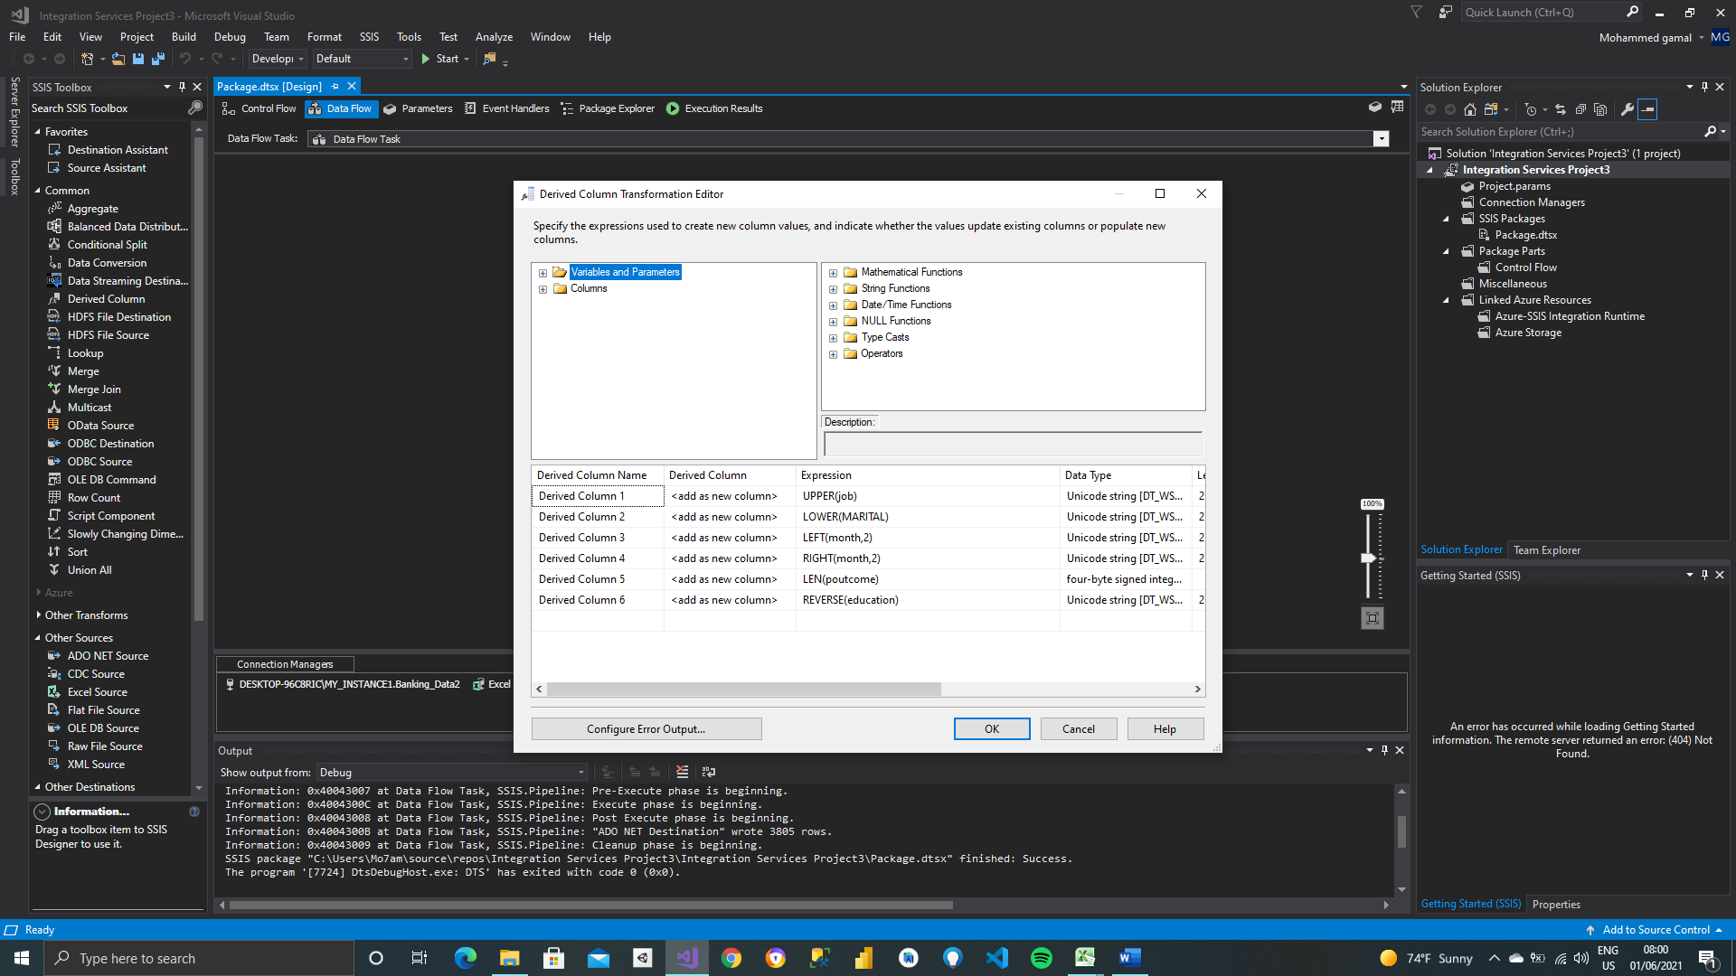

* After modification:

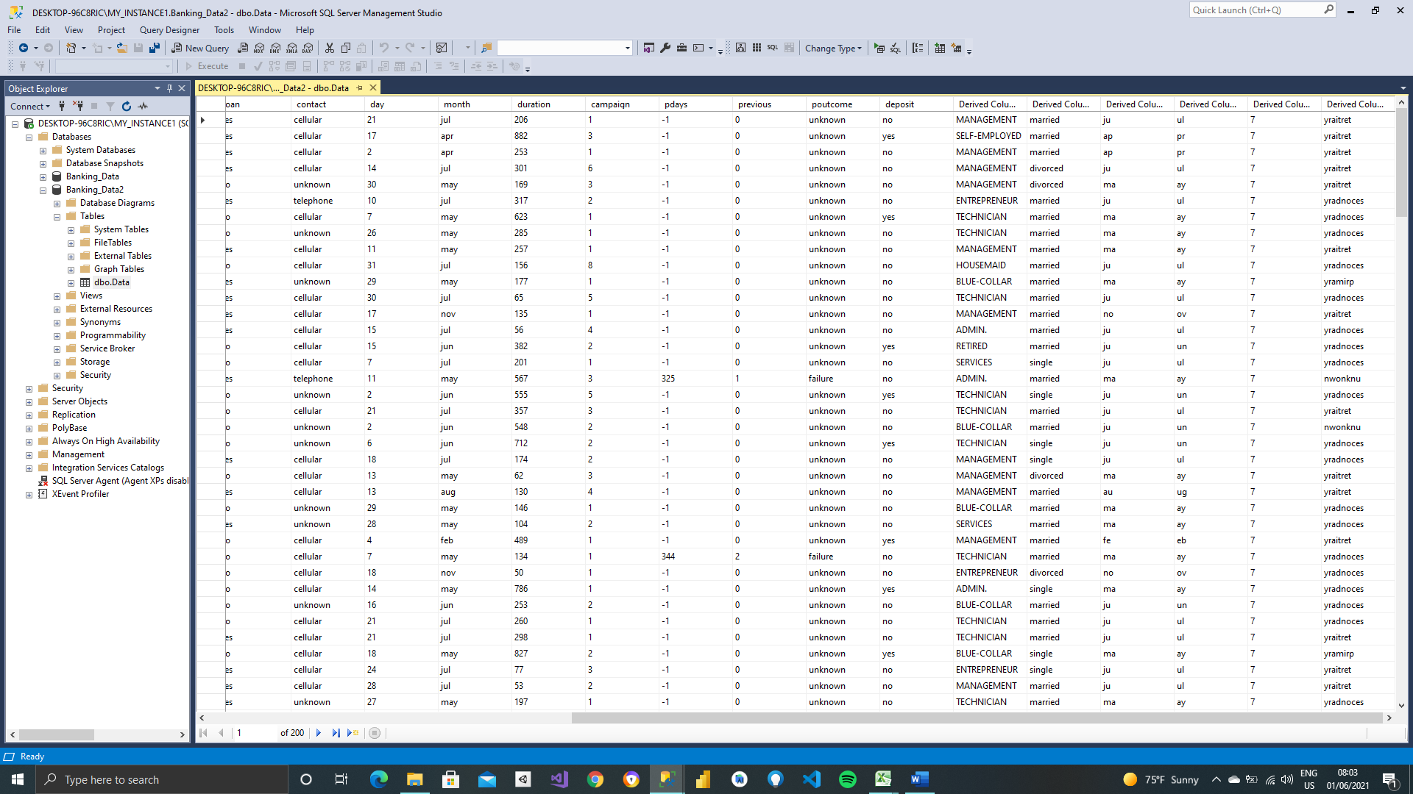

* Analysis and charts:

Dashboard:

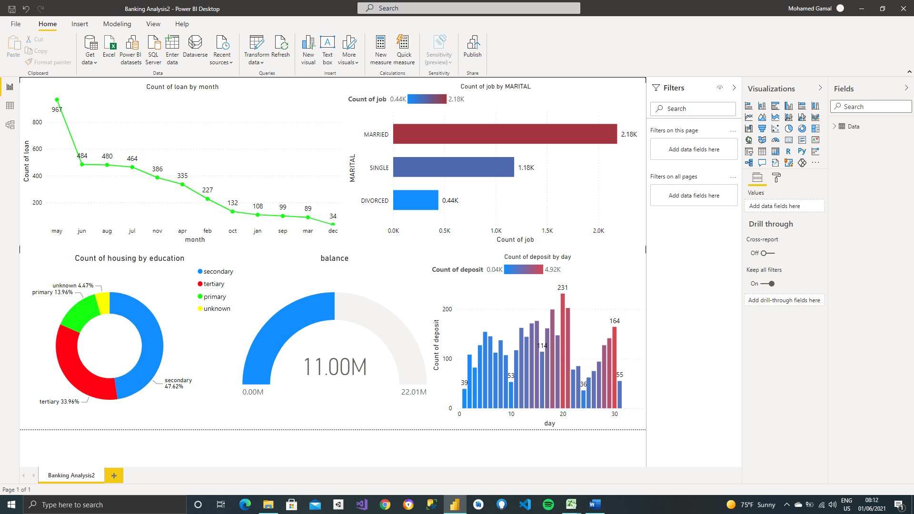

* Balances of Clients:
* Describes average balances in their accounts of clients.

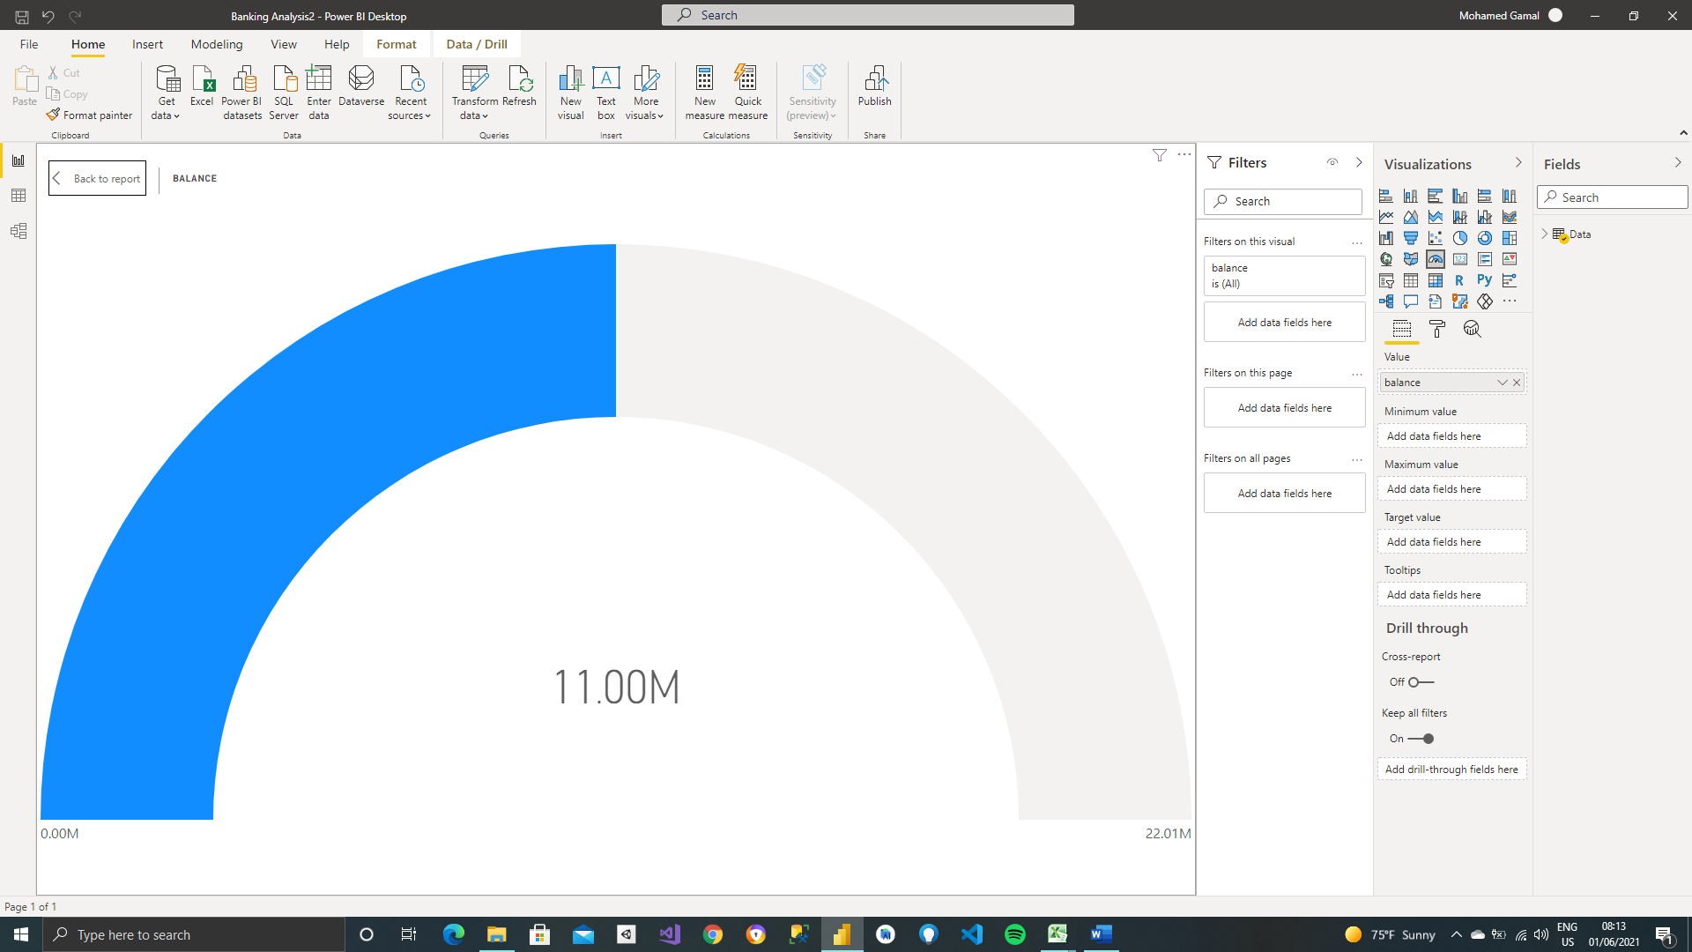

* Loan of Clients by month:
* it describes average loans that clients borrow per month to know if bank is achieved profit or not.

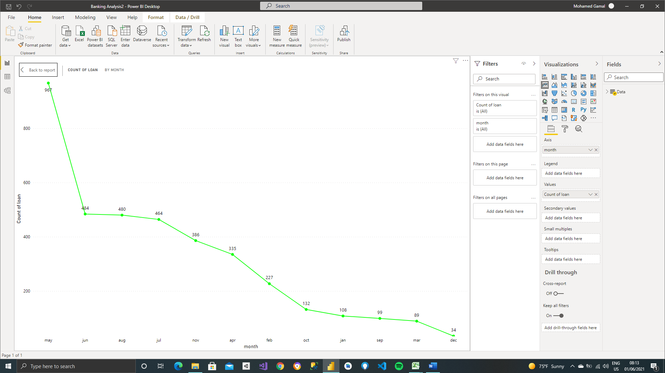

* Marital with Job:
* It describes ratio between marital status and job for
* it noticed most of jobs married from relation

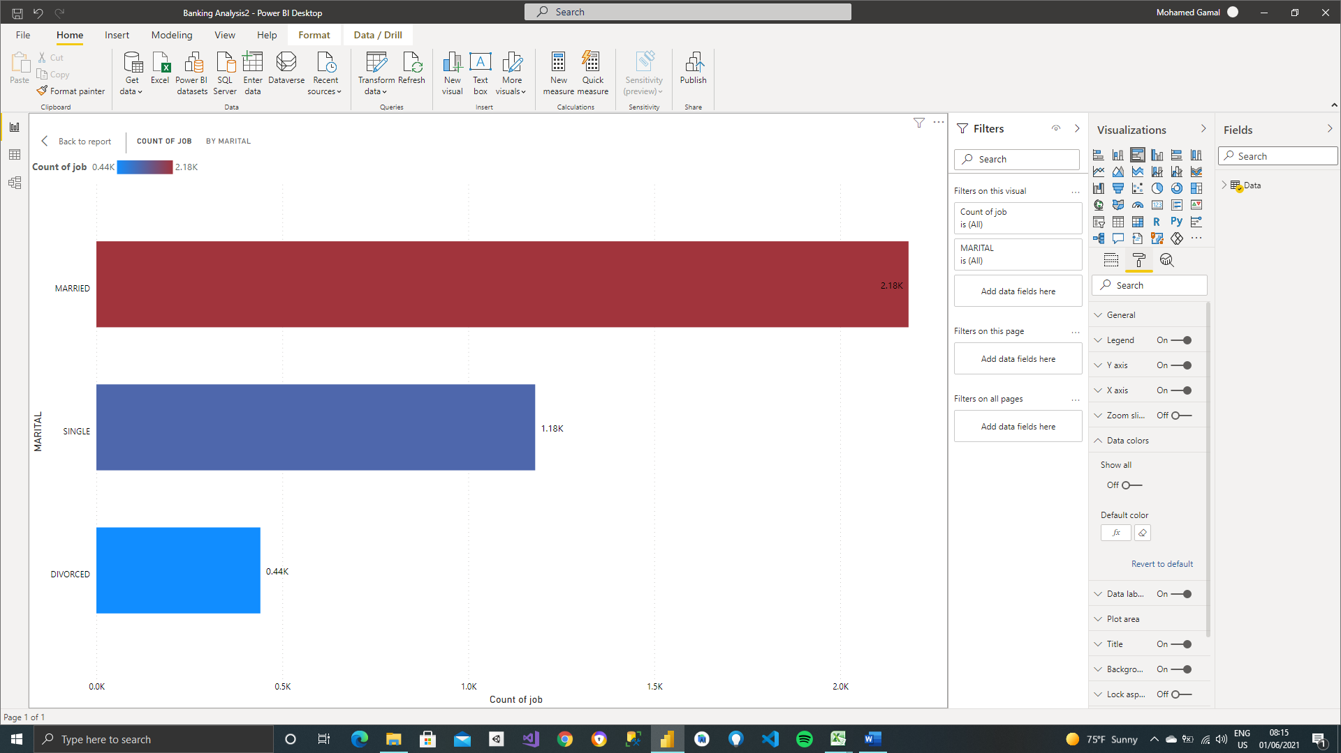

* Housing by education:
* this relation between education and having housing

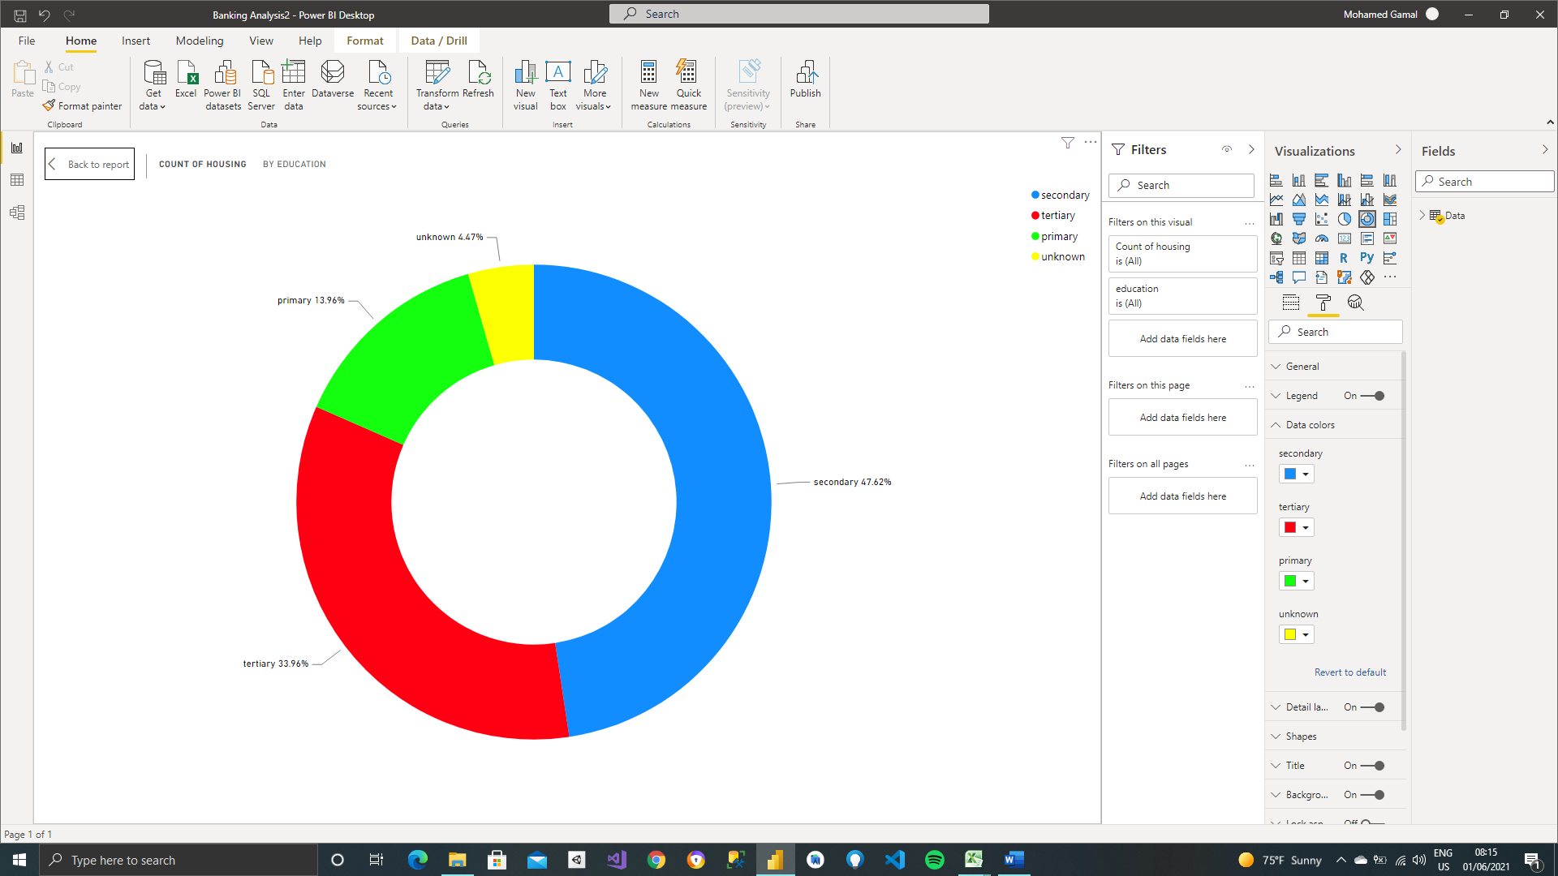

* Count of deposite by day:
* Its ratio between average deposits that is putted in a bank per day.

